Domain Driven Design

Educational Application

           Student, Teacher, Course, Department, Subject

Banking Application

           Account, Customer, Fund Transfer …

Retail Application

           Product, Order, Cart, Payment

-- create

CREATE TABLE students (

empId int primary key,

name varchar(20),

dept varchar(20),

join_date date

);

-- insert

INSERT INTO students VALUES

(1,'Amit Sharma', 'Data Engineering' ,'2025-09-15'),

(2,'Neha Verma' ,'Data Science' ,' 2025-09-17'),

(3,'Rohit Iyer', 'Data Engineering' , ' 2025-09-20');

-- fetch

SELECT * FROM students;

SELECT name, dept FROM students;

--Students in Data Engineering

SELECT * FROM students WHERE dept = 'Data Engineering' ;

--Students who joined after 2025-09-15

SELECT * FROM students WHERE join_date > '2025-09-15'

SELECT * FROM students WHERE dept ='Data Engineering' AND join_date > '2025-09-15';

-- Students in either 'Data Science' or 'A1'

SELECT * FROM students

WHERE dept IN (' Data Science', 'AI' );

--Students who joined between Sept 15 and Sept

SELECT * FROM students

WHERE join_date BETWEEN '2025-09-15' AND ' 2025-09-20' ;

SELECT * FROM students WHERE name LIKE 'A%';

SELECT * FROM students WHERE name LIKE '%a';

SELECT * FROM students WHERE name LIKE '%it%' ;

UPDATE students

SET dept =' Advanced Data Engineering'

WHERE empId =1;



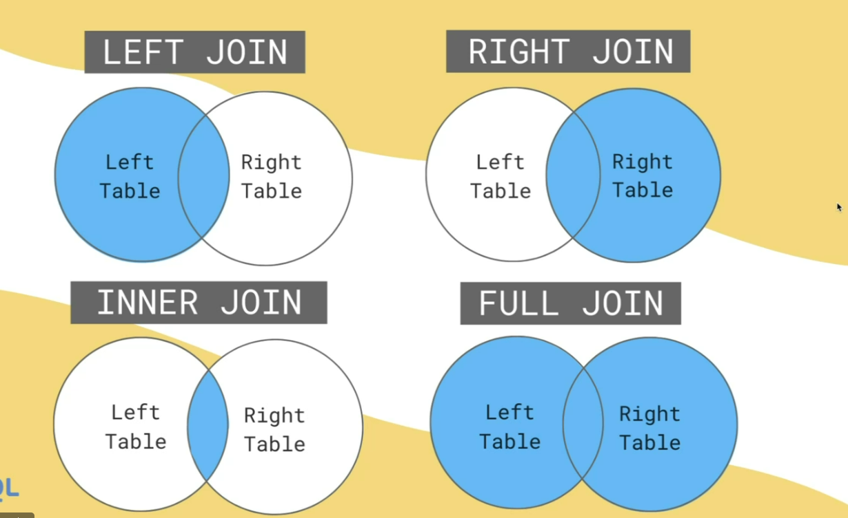

SELECT e.emp_name, d.dept_name

FROM employees e

JOIN departments d ON e.dept_id = d.dept_id

WHERE e.salary > 40000;

SELECT dept_name

FROM departments d

LEFT JOIN employees e ON d.dept_id = e.dept_id

WHERE e.emp_id IS NULL;

SELECT d.dept_name, COUNT(e.emp_id) AS total_employees

FROM departments d

LEFT JOIN employees e ON d.dept_id = e.dept_id

GROUP BY d.dept_name;

SELECT emp_name

FROM employees

WHERE dept_id IS NULL;